Paying Australian Bank Accounts

NBI Payment Option
The payment system has an option to use NBI payments that allows direct credits to Australian bank accounts. Currently it works with ANZ online banking.
An alternative to pay owners that do not have NZ based bank account, is payment by cheque where possible.
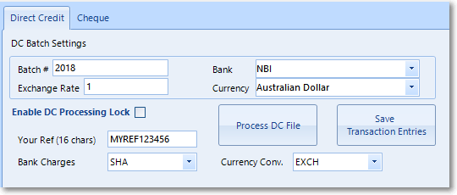

Bank Fees
Banks may charge a fee per overseas transactions. Please discuss with your bank.

Trust Group Detail
Ensure the bank account name and number, that the payments are being made from, are entered against the trust group
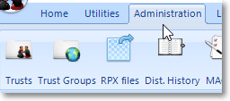
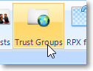

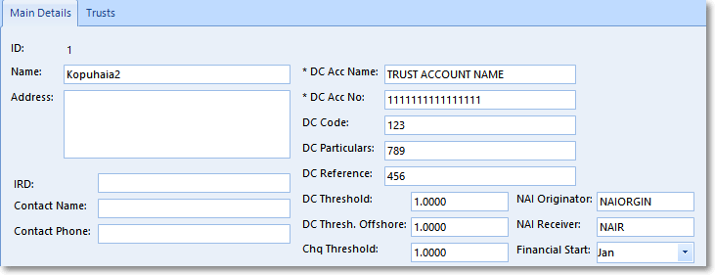
Minimum:
- DC Acc Name
- DC Acc No

Regions
ANZ requires the bank file to contain the owner’s country code (for example AU for Australia) and city. These are to be entered into the regions list and then assigned against the owner record.
This is a new requirement enforced by the bank.
First, add the country code – city combinations:
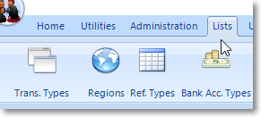
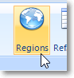
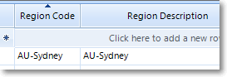

Then assign to the owner record:
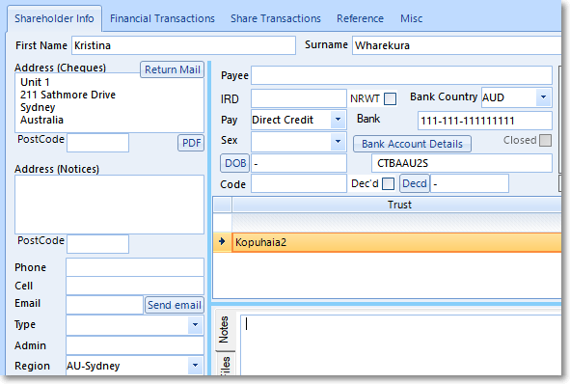
Minimum requirements
- Bank Country set to AUD (for Australia payments)
- Pay set to Direct Credit
- Bank Account Details set to SWIFT code
- Region set to the country code – city combination

SWIFT Code
The SWIFT code is required in order to process the payment. The code is provided by the owner otherwise the owner will need to contact their bank in order to obtain the SWIFT code.

Create Payment File
The process to pay Australian accounts is the same process as NZ accounts.
- Set Bank to NBI
- Set Currency to Australian Dollar
There are options that need to be selected. Please discuss with your bank on which options pertain to you.
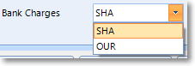
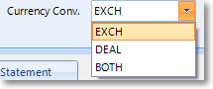

Technical reference
https://www.anzdirect.co.nz/_dlcommon/assist/online2015/Appendices/International_Bulkload_Specifications.htm

